Purpose, Passion, Mission
Memorials
How to Read
The Purpose of a memorial will usually be stated explicitly in text on the site, but it will also be embodied in the textures, the fonts, the lights and shadows of the inscription(s), the emblems and statuary. Chosen materials are always significant. Color and substance matter. Your attention and access to the memorial are directed purposefully.
The Passion and emotion of a memorial may be subtle. You may have to seek it in conversations with those who work there every day and who try to thank you for doing your duty by coming there. It may be hard to find when kids are running in and out of bomb craters, but it will make itself felt.
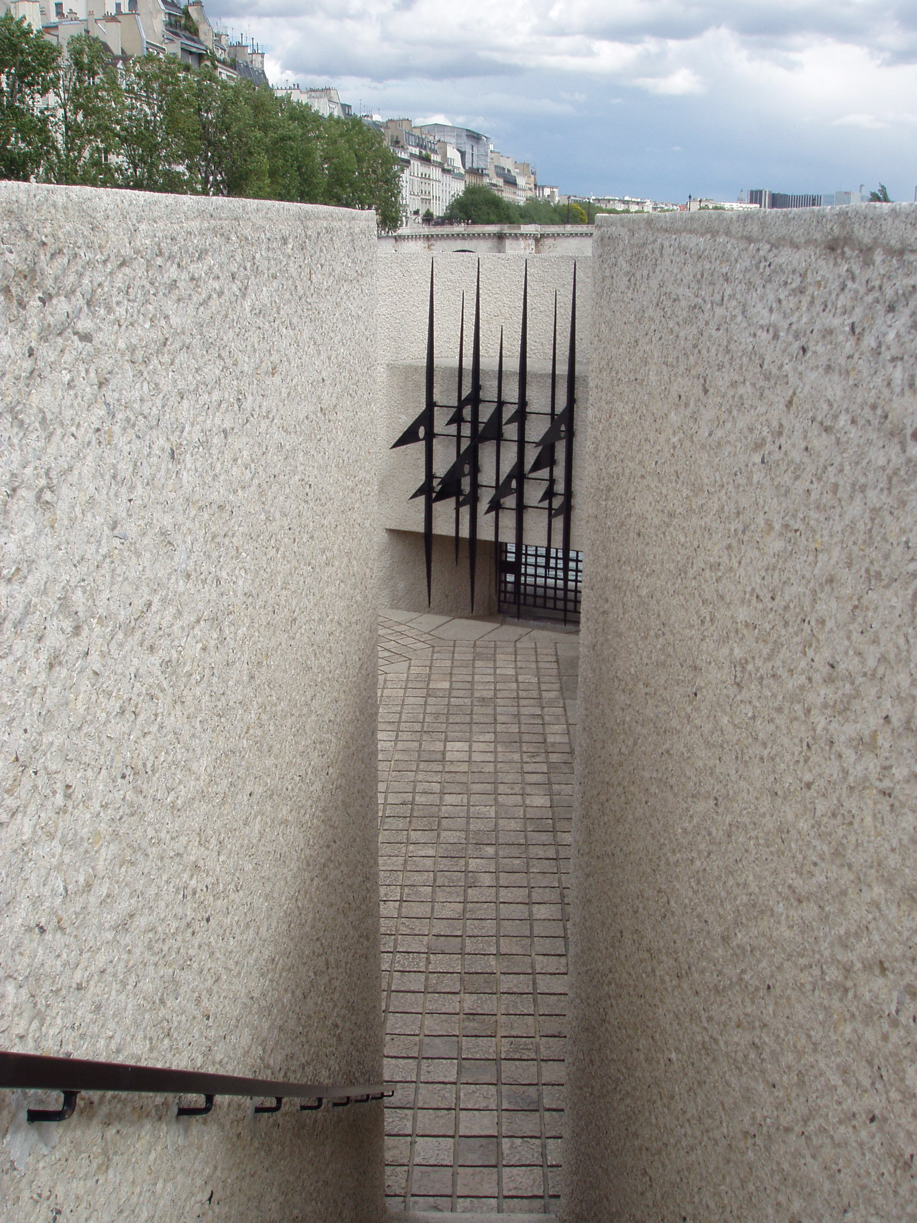
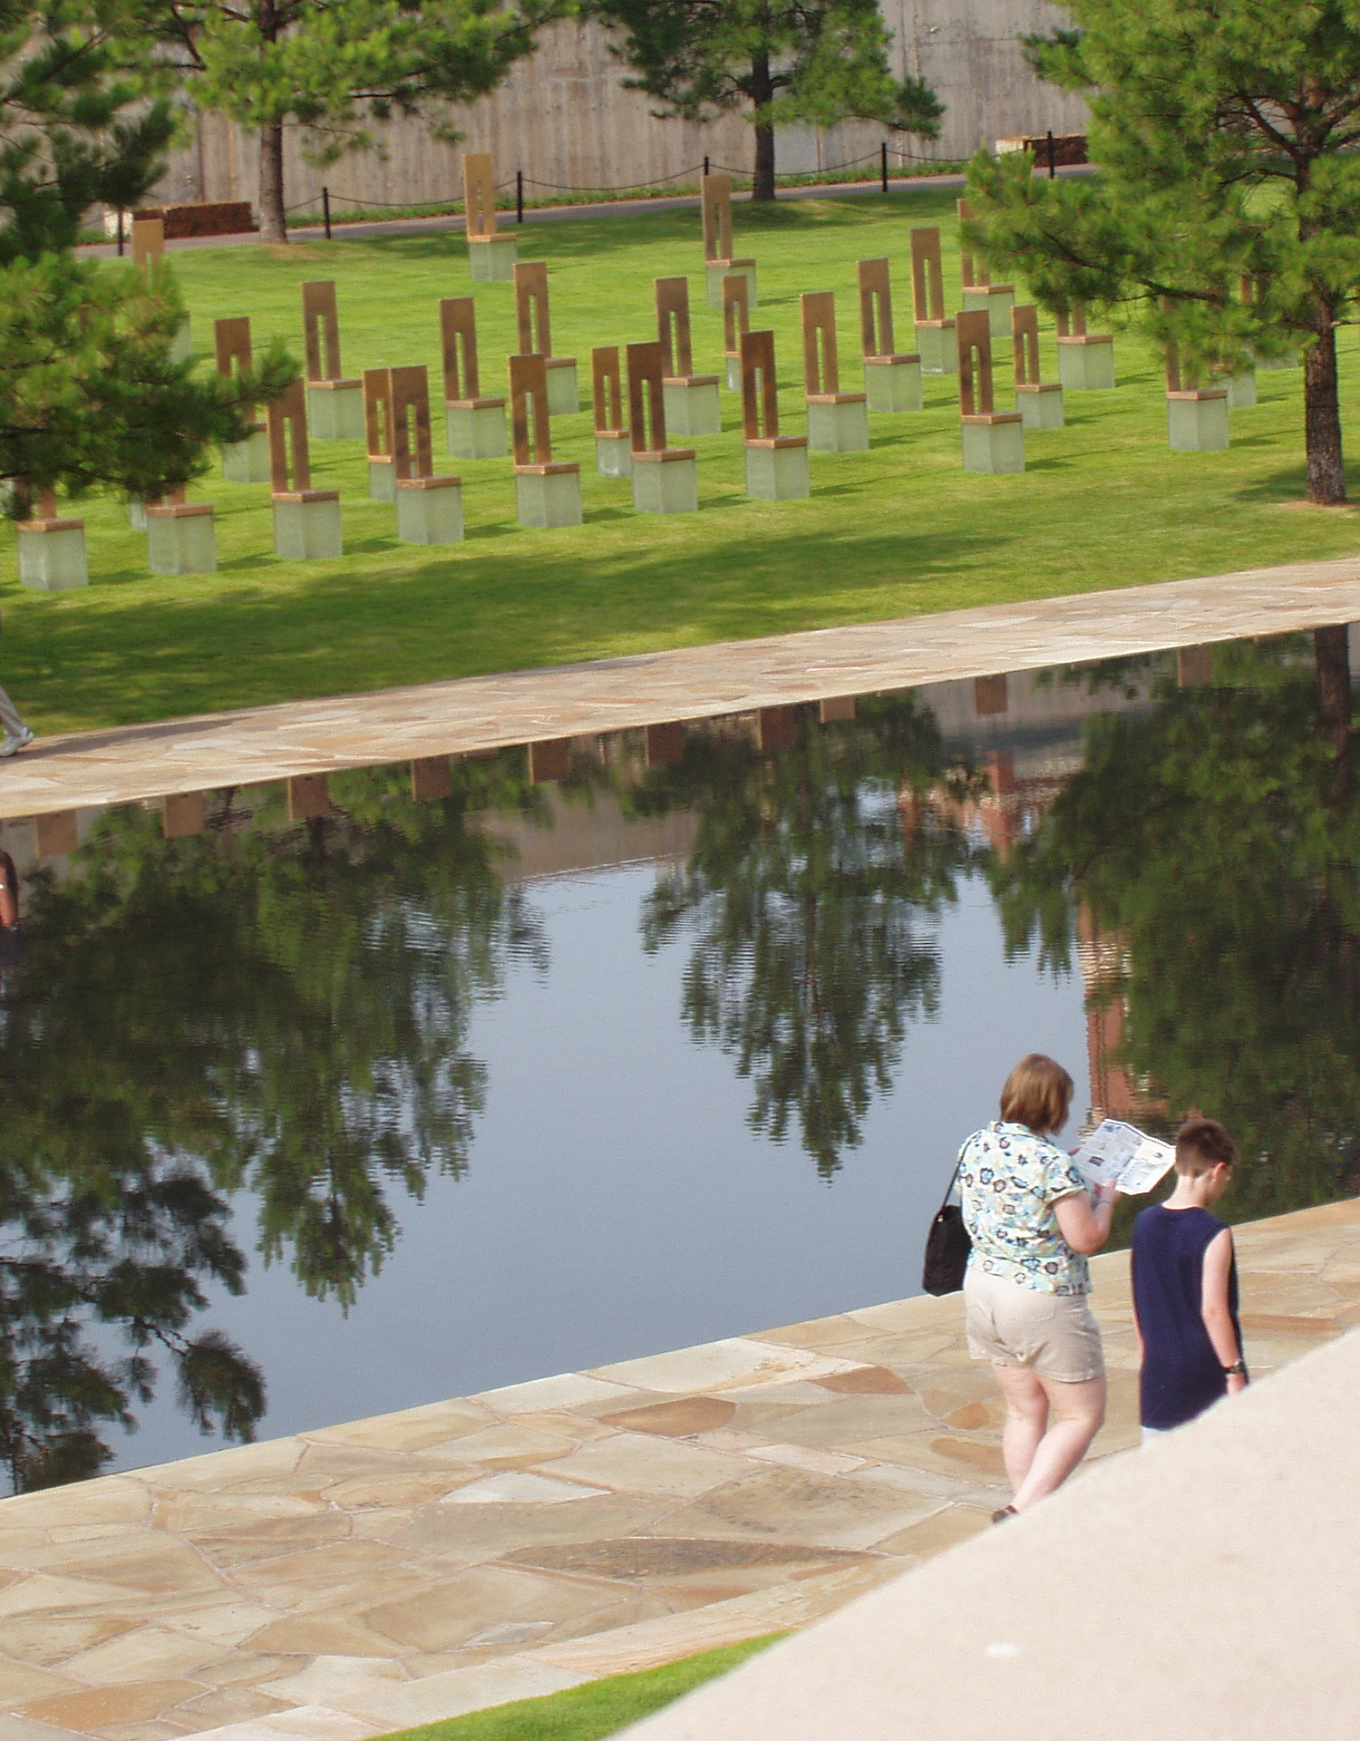
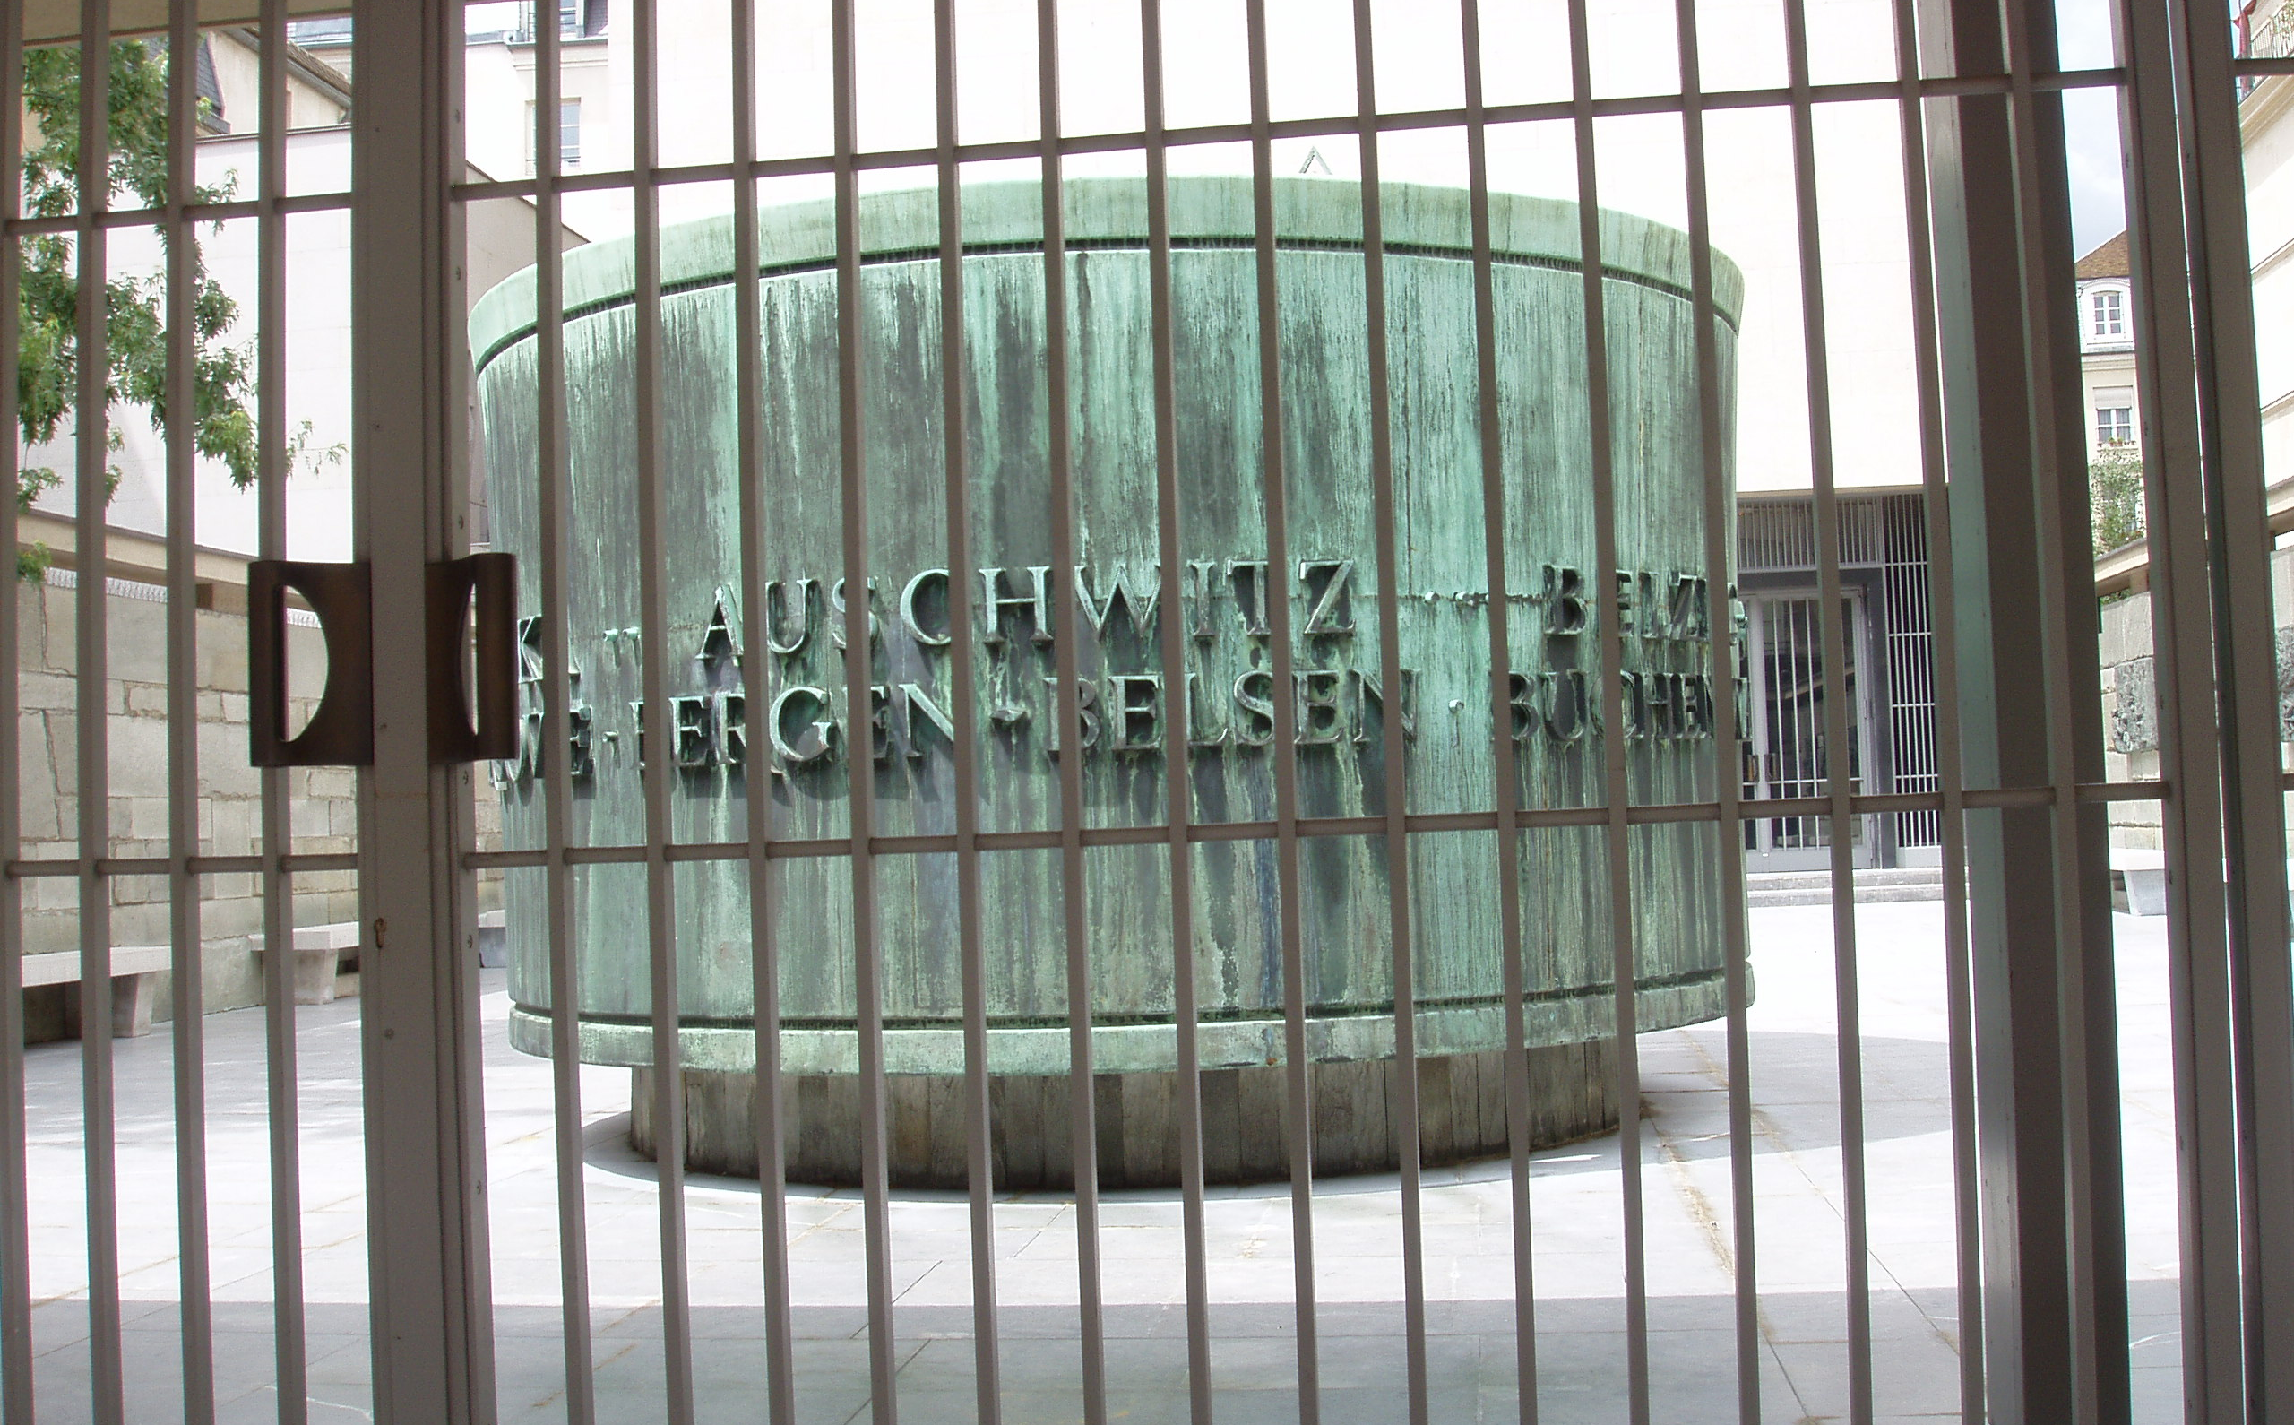
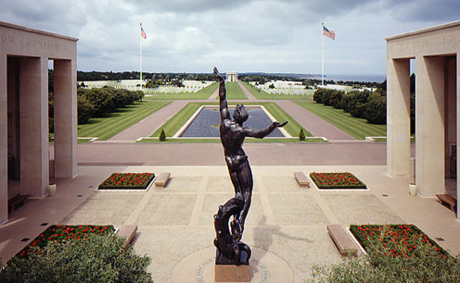
The Mission of a memorial is often directly stated but you may have to search for it. An important part may be educational outreach to teachers and students or traveling expositions designed to bring the memorial to those who cannot visit physically.
∑

∂

† Anytown, Anystate, Anycountry ¢
“We come here to remember those who were killed, those who survived and those changed forever. May all who leave here know the impact of violence. May this memorial offer comfort, strength, peace, hope and serenity.” – Oklahoma City National Memorial & Museum

How to Read

Writing Assignment
Examine your memorial, making a sketch of the physical layout. What are the exact physical materials -- copper, granite, concrete, water, oak, ivy, lavender? Even an empty space is important. Materials have symbolic meanings. Do you hear anything? Is there somewhere you could sit, think, reflect, write? Every single detail of your memorial was carefully planned. Consider the effect of your memorial and how that effect was created?

Sandra Effinger

http://homepage.mac.com/mseffie
mseffie@mac.com
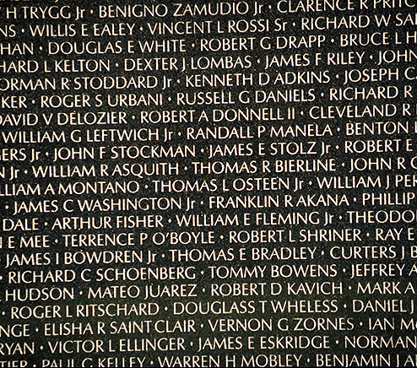
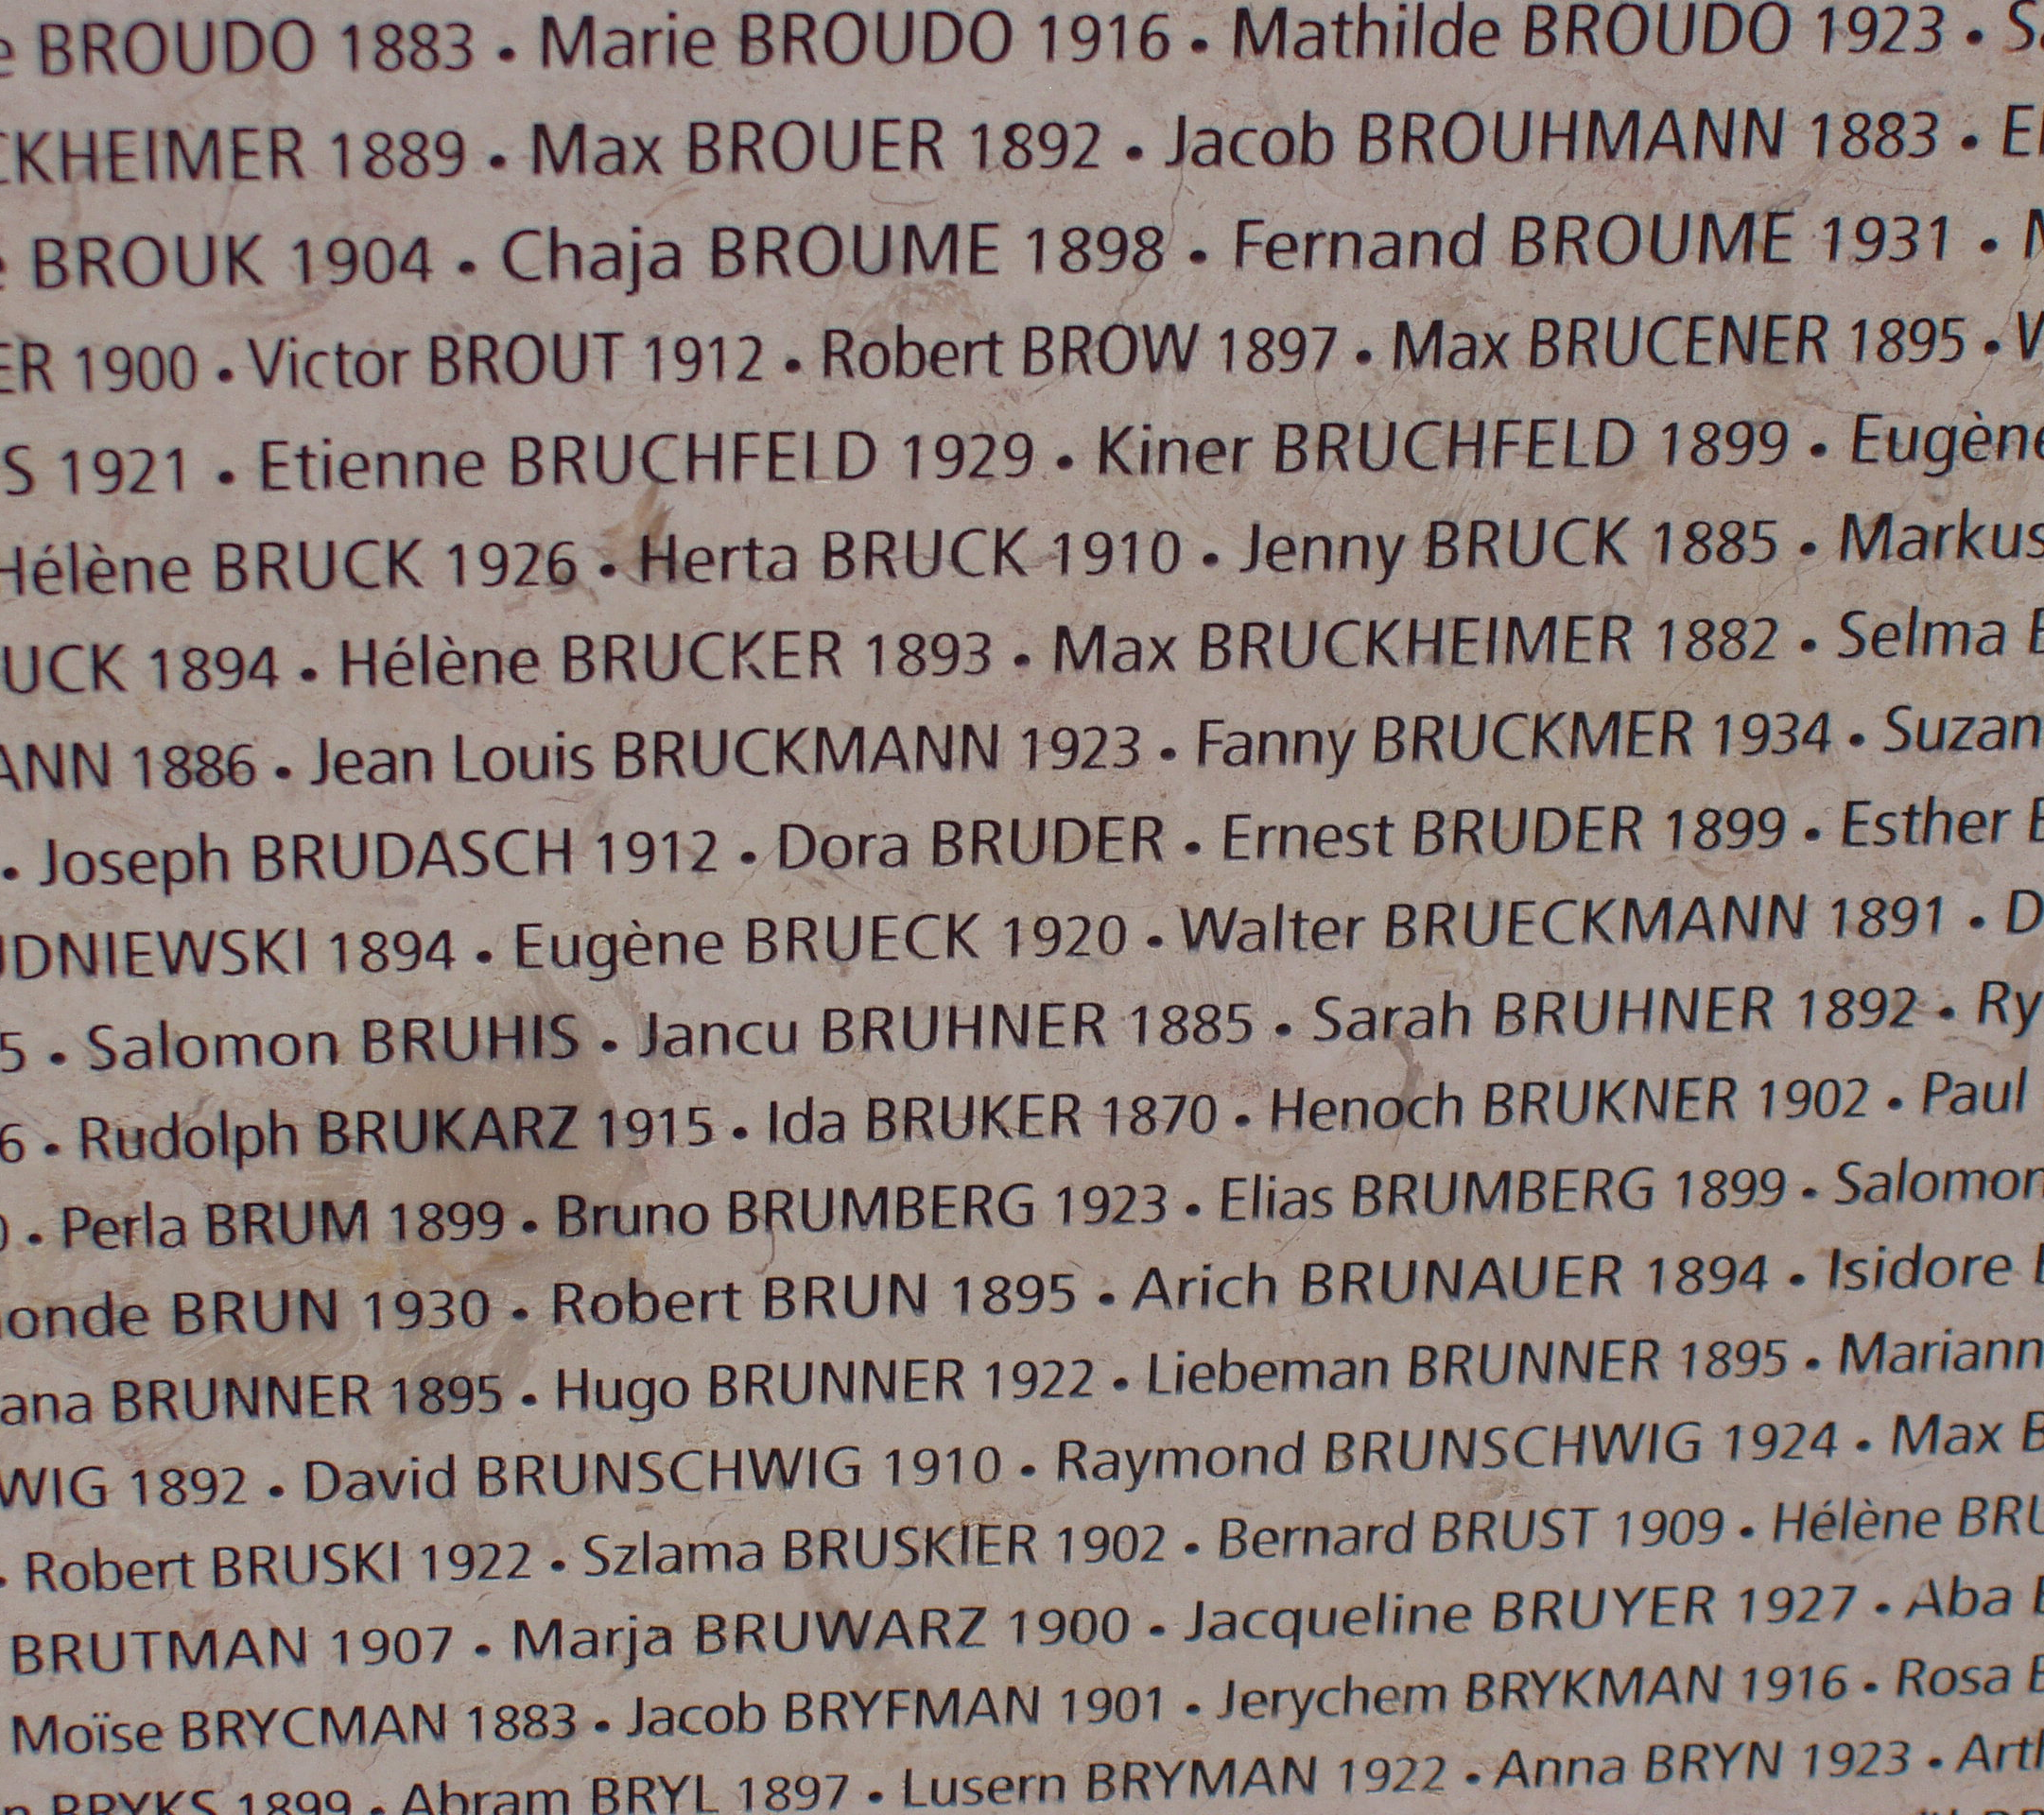
The Power of Names
A common feature of many memorials is a wall of names -- a personal touch, a way to look for oneself in the memorial. Even the physicality of touching a name on a wall empowers the experience. Additional resources where one can research the names or leave memorials, from a lit candle or a personal memento to a written text, allow a connection between the memorialized dead and the reverent living.

A common feature of many memorials is a wall of names -- a personal touch, a way to look for oneself in the memorial. Even the physicality of touching a name on a wall empowers the experience. Additional resources where one can research the names or leave memorials, from a lit candle or a personal memento to a written text, allow a connection between the memorialized dead and the reverent living.
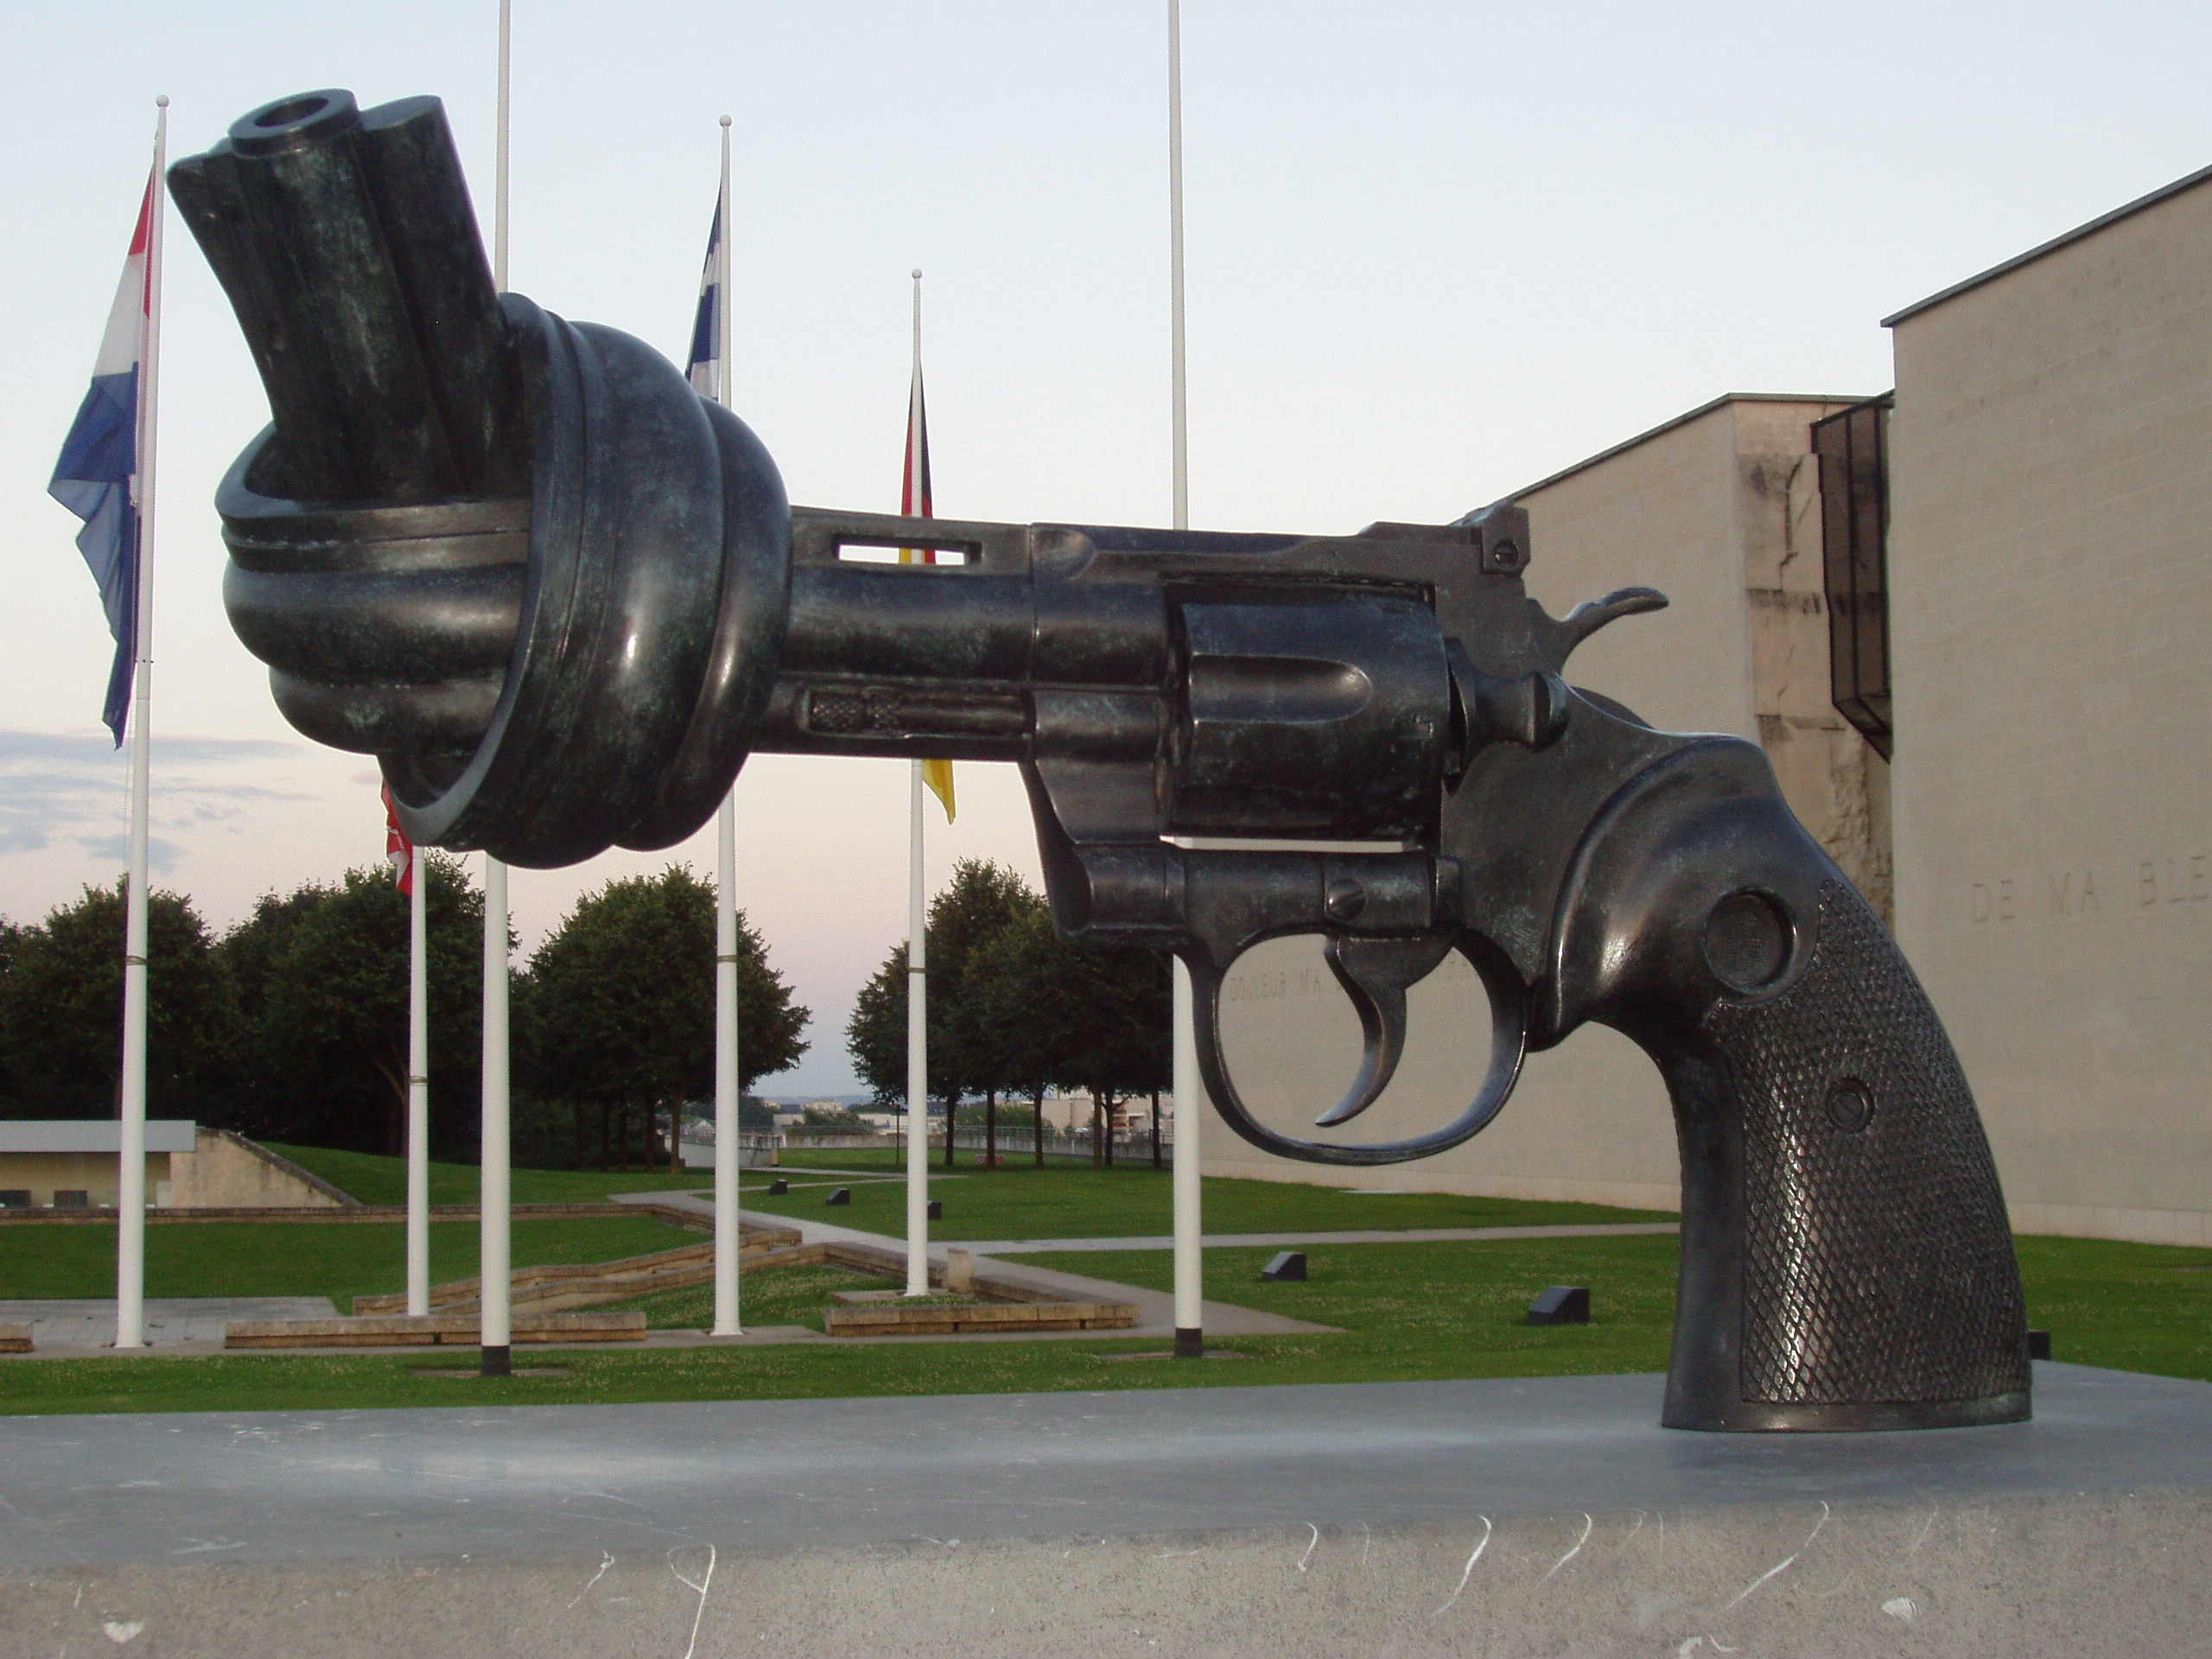
Maya Lin, the designer of the original Vietnam Memorial, conceived of the Wall as a “rift in the earth, found in a park-like setting.” The wings of the Wall anchor the Memorial in the context of the National Mall, pointing toward the Lincoln Memorial and the Washington Monument. She envisioned people approaching the Wall from the southeast in a way that the list of names would be “seemingly infinite in number” and “convey the sense of overwhelming numbers while unifying those individuals into a whole.” Her concept for the area of the Memorial grounds visually engaged by the Wall would be “a quiet place meant for personal reflection and private reckoning,” where “its walls contribute to the serenity of the area.
Online Memorials
Oklahoma City Bombing Memorial & Museum | http://www.oklahomacitynationalmemorial.org/
The Virtual Wall: Vietnam Veterans Memorial | http://www.virtualwall.org/
United States Holocaust Memorial Museum | http://www.ushmm.org/
Holocaust Museum Houston | http://www.hmh.org/
Mémorial de la Shoah | http://www.memorialdelashoah.org/
Arlington National cemetery | http://www.arlingtoncemetery.org/
American Battle Monuments Commission | http://www.abmc.gov/home.php
Caen Mémorial: Cité de l’Histoire pour la Paix | http://www.memorial-caen.fr/fr/index.php
Virtual Is Close to Being There
We found memorials as small in scale as those honoring local neighborhood losses and as vast as those honoring the thousands lost on D-Day.
Maya Lin, the designer of the original Vietnam Memorial, conceived of the Wall as a “rift in the earth, found in a park-like setting.” The wings of the Wall anchor the Memorial in the context of the National Mall, pointing toward the Lincoln Memorial and the Washington Monument. She envisioned people approaching the Wall from the southeast in a way that the list of names would be “seemingly infinite in number” and “convey the sense of overwhelming numbers while unifying those individuals into a whole.” Her concept for the area of the Memorial grounds visually engaged by the Wall would be “a quiet place meant for personal reflection and private reckoning,” where “its walls contribute to the serenity of the area.”

Text, Context, and Subtext

